**M. Musbah Rashid**

**24K-0588**

**Lab 03 Tasks:**

1. **Explain the output of this C program. Why the wrong value is being displayed in the output?**

The entered value is exceeding the range of a 32 bit signed integer and resulting in an overflow which causes it to wrap around to a negative value and show the wrong output.

1. **Write a C program that finds the largest of three numbers entered by the user.**

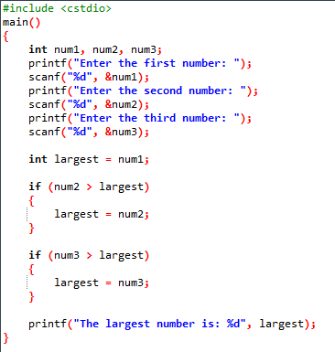

1. **A travel agency asks you to develop a program in C that can convert an amount from one currency to another. The user should input the amount in their local currency and the conversion rate for the desired foreign currency. The program should then output the equivalent amount in the foreign currency.**

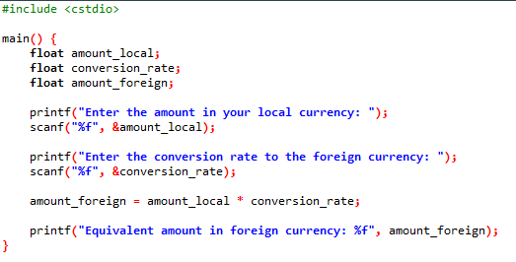

1. **Write a C program that determines whether a number provided by the user is even or odd.**

1. **Write a C program to calculate the discounted price of an item based on original price between Rs.100 and Rs. 50,000. Discount rate between 5% and 30%. Calculate the final price after applying the discount. Validate inputs and provide error messages if they are out of range. Display the final price after discount.**

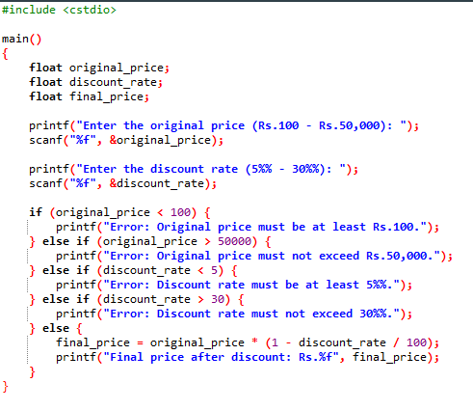

1. **Write a C program to calculate the volume of a cylinder given its radius and height. Use the formula: Volume = π r2 h where π is approximately 3.14159. Format the result to 3 decimal places.**

